In this assignment, you will develop a calculator app using JavaScript and jQuery.

In completing this assignment, you will:

* Use the jQuery library to select HTML elements and modify their contents
* Define callback functions that are invoked as the result of user actions in the HTML page
* Assemble a JavaScript application consisting of multiple functions

**Debugging/Error Note:**

In this assignment, DO NOT use any ES6 notation, as the autograder will not catch it. Additionally, do not use anything other than Class or ID selectors, such as $(.myClass) or $(#myID). Do not change the existing IDs in the HTML document, but you are free to add HTML elements, such as Classes.

**Offline Grading Note:**

Upon submitting to Codio, if you are failing far more tests than you expected, try the following:

* Add "use strict"; (including the quotes) to the top of your file (This fixes a LOT of peoples' problems).
* Avoid ES6 syntax (Use "var" instead of "let")
* Use the Class and ID jQuery selectors instead of HTML element selectors
* Declare all variables before they are used. Make sure they do not pass out of scope when they are used again

If you have done the above and are still running into these errors, we will grade your code manually. However, because this can take a lot of time if many people are posting, you are limited to ONE submission. If you receive a passing grade, we will not entertain regrade requests out of fairness to the TAs' time. Make sure you test your calculator thoroughly (the cases outlined in the homework), upload your submission to Codio, and make a comment on the Offline Grading post in the Discussion forum. Make sure you're not posting anonymously! We need to know who you are!

If you run into errors/bugs/don't understand the output that Codio is giving you, please post in the Discussion Forum and a TA will assist you! Please do NOT email Codio as they will not review any errors you are getting.

**Background**

We will provide you with the HTML that renders a simple calculator that looks like this:

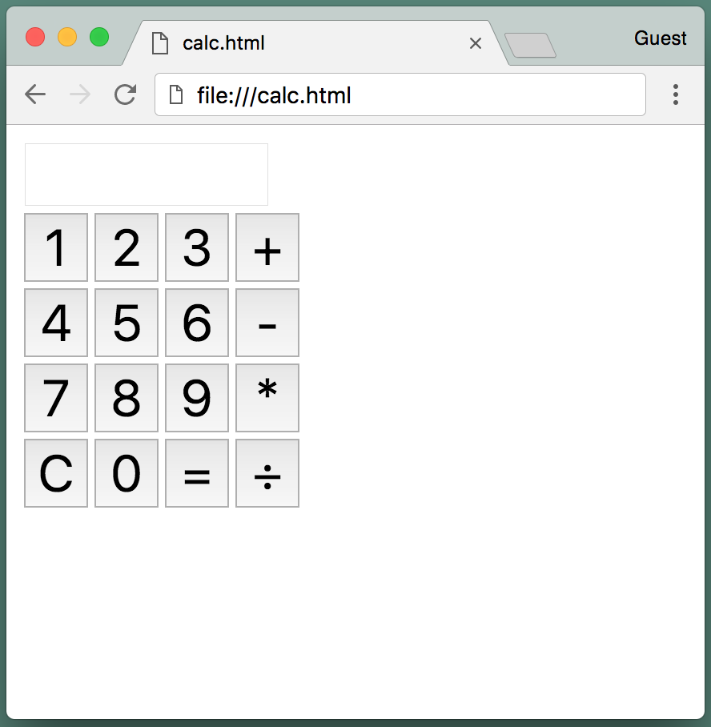

In this assignment, you do not need to modify the appearance of the calculator, you only need to implement the functionality of entering values and performing arithmetic operations using JavaScript in the web page and jQuery to access the HTML elements.

**Getting Started**

Start by downloading the three files you will need for this assignment:

* Right-click [**this link**](https://courses.edx.org/asset-v1:PennX+SD4x+3T2019+type@asset+block/calc.html) to save "calc.html" to your computer
* Right-click [**this link**](https://courses.edx.org/assets/courseware/v1/d01791a3f82df7b8a59add453d0d077c/asset-v1:PennX+SD4x+3T2019+type@asset+block/calc.js) to save "calc.js" to your computer
* Right-click [**this link**](https://courses.edx.org/assets/courseware/v1/c9f5aeeca3ad37bf2aa006139b935f0a/asset-v1:PennX+SD4x+3T2019+type@asset+block/jquery.js) to save "jquery.js" to your computer

The calc.html file is an HTML page that you can open in your browser and consists of the basic layout of the HTML elements that comprise the calculator. In particular, this page provides the HTML for:

* An input field at the top with the ID “display,” which is where the calculator’s output will be shown. This field is marked as “disabled” so that the user may not directly enter values into it.
* Buttons for the digits 0-9, with IDs “button0,” “button1,” etc.
* Buttons for the add, subtract, multiply, and divide operations, with IDs “addButton,” “subtractButton,” etc.
* Buttons with the IDs “equalsButton” and “clearButton”
* A span with the ID “output” that you can use for debugging and displaying other output, but is not part of the calculator function itself

At the top of calc.html is a <script> tag that includes “jquery.js,” which links the page with the jQuery library. Please be sure to use the version of jQuery that you downloaded from this page and not a different one, as this is the one that will be used during grading.

Also at the top of the file is some CSS that modifies the appearance of the buttons and input field to make them a little bigger and easier to read. You may change this CSS styling if you prefer; it will not be considered for grading.

Last, at the bottom of calc.html is a <script> tag that includes “calc.js,” which is where you will implement all of the JavaScript/jQuery code.

**Activity**

In calc.js, write the JavaScript code using jQuery to implement the calculator functionality. Your calculator should work as a “normal” calculator would be expected to operate, but here are the different use cases that your app needs to consider:

**Case #1. Performing an operation on two numbers**

|  |  |  |
| --- | --- | --- |
| Step | Action | Display (using example values) |
| 1 | The page is first loaded | (empty) |
| 2 | The user clicks a numbered button, e.g. “4” | 4 |
| 3 | The user clicks another numbered button, e.g. “3” | 43 |
| 4 | The user clicks an operator button, e.g. “+” | 43 |
| 5 | The user clicks a numbered button, e.g. “7” | 7 |
| 6 | The user clicks another numbered button, e.g. “1” | 71 |
| 7 | The user clicks the equals button. In this case, the app performs the most recent arithmetic operation on the two most recent numbers that were input | 114 |

**Other considerations:**

* If the user chooses the divide operation and the result is not an integer, it should be displayed using floating point notation, e.g. “10” divided by “4” should produce “2.5”.
* If the user chooses the subtract operation and the result is negative, it should be displayed as a negative number, e.g. “5” minus “8” should produce “-3”. This includes subtracting from zero, too, of course.
* If the user attempts to divide by 0, the result should be shown as “Infinity”.

**Case #2. Continuing an operation**

|  |  |  |
| --- | --- | --- |
| Step | Action | Display (using example values) |
| 1 | Steps 1-7 for Case #1 above | 114 |
| 2 | The user clicks an operator button, e.g. “-” | 114 |
| 3 | The user clicks a numbered button, e.g. “5” | 5 |
| 4 | The user clicks another numbered button, e.g. “2” | 52 |
| 5 | The user clicks the equals button. In this case, the app performs the arithmetic operation on the result of the previous operation and the one that was most recently entered | 62 |

**Case #3. Starting a new operation**

|  |  |  |
| --- | --- | --- |
| Step | Action | Display (using example values) |
| 1 | Steps 1-7 for Case #1 above | 114 |
| 2 | The user clicks a numbered button, e.g. “1” | 1 |
| 3 | The user clicks another numbered button, e.g. “0” | 10 |
| 4 | The user clicks an operator button, e.g. “*” | 10 |
| 5 | The user clicks a numbered button, e.g. “6” | 6 |
| 6 | The user clicks the equals button. In this case, the app performs the arithmetic operation on the two numbers that were input, and ignores the result of the previous operation | 60 |

**Case #4. Performing an operation on multiple numbers**

|  |  |  |
| --- | --- | --- |
| Step | Action | Display (using example values) |
| 1 | The page is first loaded, or a prior operation is completed using the equals button |  |
| 2 | The user clicks a numbered button, e.g. “1” | 1 |
| 3 | The user clicks another numbered button, e.g. “3” | 13 |
| 4 | The user clicks an operator button, e.g. “+” | 13 |
| 5 | The user clicks a numbered button, e.g. “7” | 7 |
| 6 | The user clicks an operator button, e.g. “-”. In this case, the app performs the arithmetic operation on the two numbers that were input, using the operator that was selected between entering them. | 20 |
| 7 | The user clicks another numbered button, e.g. “2” | 2 |
| 8 | The user clicks the equals button. In this case, the app performs the arithmetic operation on the result of the previous operation and the one that was most recently entered | 18 |

After step 7, the user should of course be able to continue repeating steps 6 and 7 and performing (and seeing the result of) additional operations before selecting the equals button.

**Case 5: Using the clear button**

During or after any of the cases above, if the user clicks the clear button, then the app should reset itself back to the state in which the page was just loaded. It should not reload the page, of course, but rather should clear the display and “forget” the results of prior inputs or operations.

**Case 6: Using the equals button**

If the app is in the “reset” state – because the page has just been loaded, or because an operation was just completed, or because the user clicked the clear button – and the user enters one or more numbers and then clicks the equals button without first selecting an operator and entering another operand, the display should be the same and the equals button should be ignored. For instance, if the app is reset and the user clicks “2” and then “3” and then “=”, the display should still read “23” and that value should be used as normal for the next button click.

Likewise, if the app is in the reset state and the user enters some numbers, and then an operator, and then clicks the equals button without entering another operand, the display should be the same and the equals button should be ignored. For instance, if the app is reset and the user clicks “1” and then “5” and then “+” and then “=”, the display should still read “15” and that value and the “+” operator should be used as normal for the next button click.

However, if the user has just completed an operation using the equals button and then clicks the equals button again, the previous operation should be repeated using the result of the operation and the most recently entered operand. For instance, if the app is reset and the user enters “8” and then “+” and then “6” and then “=”, the display should read “14” as normal. If the user enters “=” again, the “+6” operation should be repeated and the display should now read “20”. If the user then enters “=” again, the “+6” operation should again be repeated and the display should read “26” and so on.

**Case 7: Selecting multiple operators**

If the app is in the “reset” state and the user enters some numbers, and then an operator, and then a different operator, the first operator should be ignored and the second operator should be used in the operation. For example, if the app is reset and the user enters “6” and then “+” and then “*” and then “2” and then “=”, the “+” operator should be ignored and the “*” operator should be used, so the display should read “12”.

**What about…?**

You may encounter other cases that are not addressed in this document, e.g. what to do when the result of an operation exceeds the largest number that JavaScript can represent, or other sequences of clicking buttons that do not follow the ones described above. You may handle those cases in any manner you choose (or ignore them entirely!) since they will not be considered for grading in this assignment.

**One more important note:**

Please do not change the IDs of any of the buttons or the “display” input field, as these IDs will be used by our tests during grading. You are free to add other attributes to the HTML elements, such as “class” attributes, but do not change the IDs.

DO NOT use any ES6 notation, as the autograder will not catch it. Additionally, do not use anything other than Class or ID selectors, such as $(.myClass) or $(#myID).

Likewise, please do not change either of the <script> tags in calc.html so that the grader can use the right .js files.

**One more important note:**

Review the past few lessons to see the syntax for selecting HTML elements and registering callback functions for events using jQuery.

Keep in mind that JavaScript will perform concatenation on string variables, even if the values are numeric. So don’t be surprised if you run into a situation in which ‘5’ + 1 = ‘51’. You can use the JavaScript Number() function to convert a string variable to a numeric variable.

**Before you submit**

Please be sure that:

* You are using the jquery.js file that we provided and have not changed either of the <script> tags in calc.html
* You have not changed the “id” attribute of any of the HTML elements in calc.html
* You have not created any additional files and all of your JavaScript/jQuery code is in calc.js

**Assessment**

Your submission will be assessed using automatic grading scripts that will check that the app works correctly for various inputs and events. Your score is determined by the percentage of these tests that “pass,” i.e. that produce the correct result for the specified input or event.

To submit your assignment, click the "BEGIN SUBMISSION" below and follow the instructions in the Codio Readme file. Be sure to upload both **calc.html** and **calc.js** for grading.

**NOTE**

We have made some improvements to this assignment in Codio!  As a result, we are retiring the older version and have started a new version.

* If you **have not** started this assignment yet, please proceed using the BEGIN SUBMISSION link below (in the **Homework #3 Submission (External Resource)** section).  There is nothing more you need to do.
* If you **have** already started this assignment in the old version, please take what you have done in the retired Codio course and submit it to the new Codio course.  To access the retired version, please login to [Codio](https://codio.com/home/student" \t "[object Object]) and open the Codio course called "*SD4X - Retired Version (Programming for the Web with JavaScript).*" Copy that to the new Codio course called "*SD4X Programming for the Web with JavaScript 2020*" (note that the new course has '2020' at the end) and proceed from there.